Lab 2 Linux

Student Name: | Marco Ho | A#: | 01338160

Part 1: Do your research to answer listed questions:
- In what language is Linux written? What does the language have to do with the success of Linux?
Answer: Linux is primarily in C, with some parts in assembly. C allows Linux to be efficient and portable across different hardware platforms.
- What is a shell? How does it work with the kernel? With the user?
Answer: The shell is a command-line interface that is used by the user to communicate with the kernel. And the kernel is a component of the OS that acts as a middleware between software and hardware.
- What happens when you give the following commands when the file named done already exists (assume to_do also exists)?
  - cp to_do done
Answer: This copies file to_do to file done and overwrite its contents.
  - mv to_do done
Answer: This will rename to_do to done and overwrite file done.
- What happens if you use diff to compare two binary files that are not identical? (You can use gzip to create the binary files). Explain why the diff output for binary files is different than the diff output for ASCII files.
Answer: The shell will display a message that indicates that they’re different. “diff” output for binary files is different when compared to ASCII files because binary files are not human-readable so there’s no reason to compare line-by-line and outline the differences.
- What does which do? What is the result of giving the which utility the name of a command that resides in a directory that is not in your search path?
Answer: Command “which” outputs the path of an executable of the provided command. If the command is not in the search path, “which” will not find the executable.
- Experiment by calling the file utility with names of files in /usr/bin. How many different types of files can you find there (approximately)?
Answer: Approximately 21 different file types

- Try giving the two commands and explain the difference between them:
  - echo cat
Answer: This echos or prints “cat” to standard output.
  - cat echo
Answer: This views the contents of utility “echo”.
- Find an existing file, or create a file that
  - gzip compresses by more than 80 per cent
Answer: Most typical files will do this
  - gzip compresses by less than 10 per cent
Answer: Files that are already compressed such as JPEGs would do this
  - gets larger when compressed with gzip
Answer: Extremely small files could do this due to addition of gzip compression header and metadata.
- One extremely useful utility is grep. Read the man page for grep and write a command to do the following:
  - display all lines starting with t or T in the file fred.txt
Answer: grep -i “^t” fred.txt
  - display all lines in the file header.h which contain write (upper or lower case)
Answer: grep -i “write” fred.txt
  - count all of the lines that are empty (use grep and wc)
Answer: grep -c “^$” Readme.md
10. What grep options will
- print only a count of matched lines
Answer: -c
- list filenames, but not matched lines
Answer: -l
- print lines and their line numbers
Answer: -n
- ignore upper and lower case distinctions
Answer: -i
11. What command will print the last 132 lines of the file test?
Answer: tail -n 132 test
12. command can you use to copy all of the files in the directory lab2 (including any subdirectories) into the directory /home/eric?
Answer: cp -r lab2/* /home/eric
13. the ls command has lots of options. What options will:
- show nonprinting characters in octal
Answer: -b | od -c
- list files by creation/modification time
Answer: -l –time=birth
- indicate file type by appending / to directories, * to executables and @ to symbolic links
Answer: -F
- list only the directory name, not its contents
Answer: -d */
- list all files, even those normally hidden
Answer: -a
- recursively list subdirectories as well as the current directory
Answer: -R
- list files according to modification time
Answer: -lt
- show permissions, owner, size, modification type
Answer: -l
14. Another extremely useful command is find. Read the man page on find and write a find command to do the following:
- list all files (and subdirectories) in your home directory.
Answer: find ~
- list all files named fred1 in the /work directory.
Answer: find /work -name “fred1”
- list all files whose name starts with “memo” and which are owed by ann in the system.
Answer: find / -name “memo*” -user ann
- list all files in the system that were modified within the last two days.\
Answer: find / -mtime -2
- use find to grep for a pattern down a directory tree. Display all lines in all files in your login directory (or subdirectories) which contain the string "ListMe" Be sure to create some test data to show this works.
Answer: find ~/testdir -type f | xargs grep -H "ListMe"

Part 2: Basic process management.
Start a process, find out what PID it is, and then stop the process.
- Start a process. For this example, the yes command will be used. The yes command outputs a bunch of y's until it is killed. This useful in certain scripts, but running it on the console is annoying, so you will want to be able to kill it. To start the yes command, run $yes in a command window.
- The yes command is now doing its thing, but it is hard to get anything done with all of those y's streaming by. So stop yes by pressing Ctrl+c.
- Next start yes in a more friendly manner. This time you will tell yes to output to /dev/null instead of the screen, and also put it in the background, so you can get a command prompt back. To do this, run $yes > /dev/null& The > character tells the system to redirect the output, in this case to /dev/null, and the & character tells the system to put the process running yes into the background.
- Now you need the process id (PID) of the new process, so you can send it a signal. Run $ps ax This will give you a list of all the processes running. Find out the PID of the process running the yes command.
- Now send a signal to kill the process, but first you need to know what signal to send. To find out what signals are available run $kill -l (the letter l, for list). The signal you want to send is SIGKILL. You can use the signal number or KILL (preceded by a -).
- The command is $kill -KILL PID or $kill -9 PID Substitute the PID of the process running the yes command, and then run that command to kill it.
Did it work? use ps again to find out if it is gone.
- As root, you can kill any process, belonging to you or anyone else. Non- privileged users can only send signals to processes they own.
Copy & paste screenshots to prove it work for you.
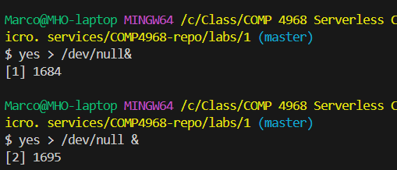
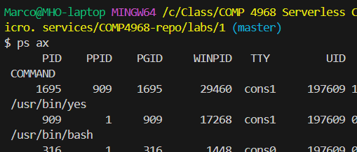
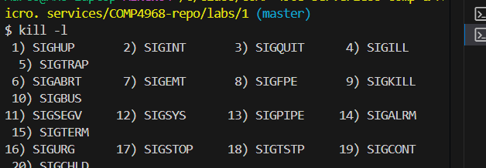
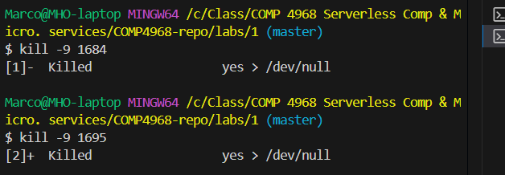
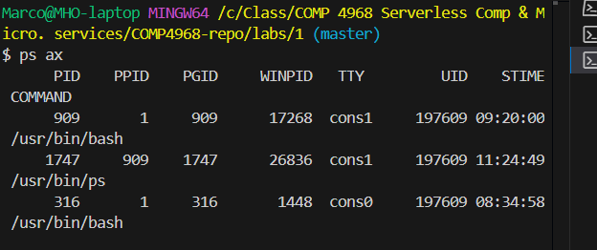

Part 3: Learn Bash Scripting @ https://learn.chef.io/tracks


Check out “Bash Scripting for Beginners” course and then submit a screenshot for your 100% completion in the box below.

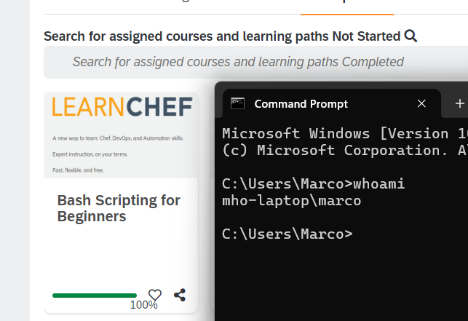

Part 4: Learn Powershell @ https://learn.chef.io/tracks

Check out “Learning Powershell” course and then submit a screenshot for your 100% completion in the box below.

